ASSIGNMENT COVER SHEET

Student ID:
bida25-081

Student names:
Craig Shonhiwa

Student email:
Bida25-081@thuto.bac.ac.bw

Cohort:
2026

Assignment title:
SCIS WMD_2026 A01

Program of study:
Business Intelligence & Data Analytics
2025-26
Year:

SECTION A
a)24/7 online-bookings
Increasing brand awareness
Building client databases to store historical data

b) The target audience for this business is mainly females.
According to (Statistics Botswana, 2022), the majority of females in the country are based in other special areas but the main cluster dense is in Broadhurst which is where the business is based.
The data was clustered as followed:

Total Population of Females (Gaborone) | 126, 352
Central | 5,826
Village | 2,467
Broadhurst | 14,623
Phase 4/ Block 8-9 | 10,101
Block 5-7 | 8,704
Naledi | 980
Remaining Areas | 83,651

Technical aptitudes
Responsiveness: added bootstrap to cater for devices with smaller or bigger viewports.
Navigation: clear menu and navigation bars with navigation links e.g Home, About Us, Services, Booking
Media optimisation: compressed pictures so as to reduce loading speed times.

c) The type of website being designed is service-based. It is primarily designed for promoting nails and booking appointments. The content being designed involve; informational content, visual content and Interactive content.
Informational content: involves the list of services available as well as the price for each service

Visual content: involves pictures videos and images such as the nail gallery which attracts users

Interactive content: involves buttons such as the “Contact Now” button. Also involves interactive forms to collect user data.

2. Site map

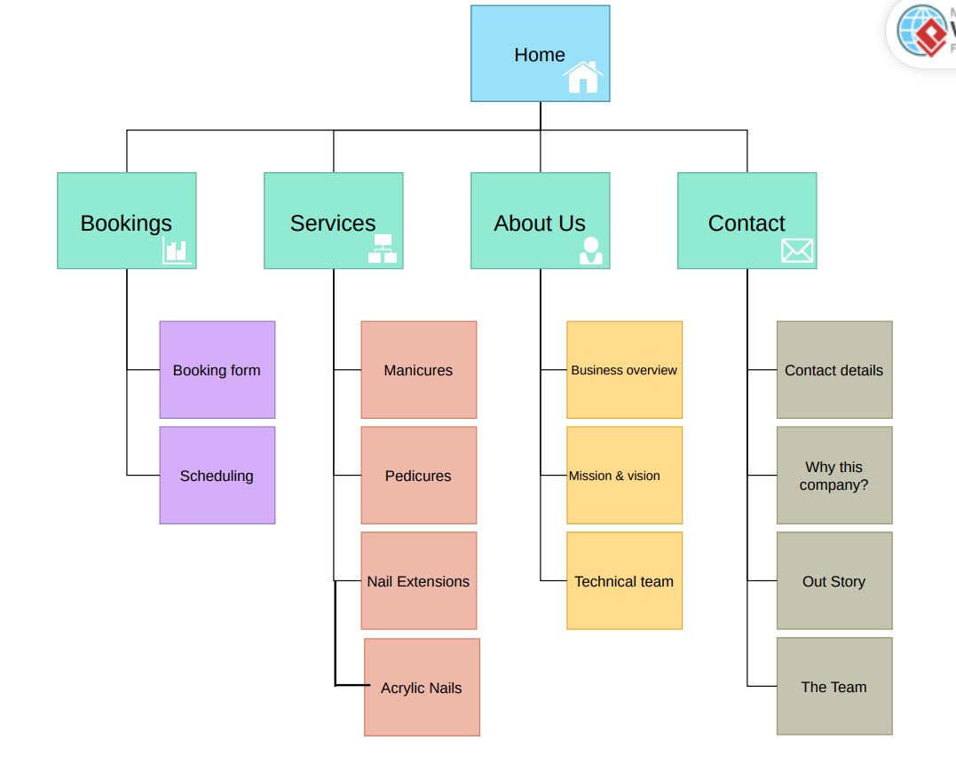
4. Technical brief
Includes the programming languages ie; HyperText Markup Language (HTML5), Cascading Style Sheet (CSS) and Javascript. Also involves use of the online hosting and deployment platform Github. Visual studio code as the text-editor. Google Fonts as the source for the fonts used on the web page. Various browsers for testing of the website ie; Google chrome, Mozilla Firefox, Edge etc. Visual Paradigm for creation of the site map.

3. Wireframes

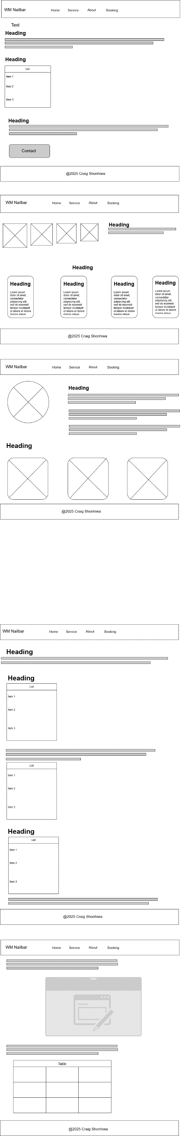




References
Botswana, S., 2022. Population of cities, towns and villages 2022. [Online]
Available at: https://www.statsbots.org.bw/sites/default/files/publications/Population%20of%20Cities%20Towns%20and%20Villages%20%202022.pdf
[Accessed 17 March 2026].

